To the Town Mayor and Councillors, Usk Town Council.
You are summoned to attend the Annual Meeting of Usk Town Council to be held at Sessions House, Usk on Monday 13th May 2019 at 6.30pm.

The business to be transacted is set out in the agenda below.
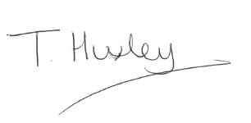Tracey Huxley (Mrs.)
Town Clerk

  - Election of Mayor for 2019/2020

  - To receive the Mayor’s DECLARATION OF ACCEPTANCE OF OFFICE

  - Election of Deputy Mayor 2019/2020

  - To receive declarations of interest in items on the agenda.

  - To receive apologies for absence.

1.6 Retiring Chairman’s report
(There will be a short interval whilst photographs are taken)

1.7 To receive Minutes of the Annual Meeting held on 14th May 2018

1.8 To review and formally adopt the model code of conduct

1.9 To review and formally adopt Standing Orders for 2019/2020

2.0 Adoption of Income & Expenditure Report for 2019/2020

2.1 Proposals for appointments of members to committees and as representatives of local
organizations.

2.2 Nominations for Town Constables.

2.3 To confirm the date for the Civic Service as Sunday 23rd June 2018

